Use Cases for "Beyond QWERTY" Project for Bank Account Opening
Steps:
- User Interaction:
  - The customer speaks into the system, providing their personal details (e.g., "My name is Awaz. I live in Nepal.”
- Voice Processing:
  - The system uses speech-to-text technology to convert the spoken input into written text.
- Language Translation
  - If the user speaks in a local language, the system translates it into the required form language (e.g., English).
- Data Mapping:
  - The system identifies which form fields correspond to the spoken data (e.g., mapping "Awaz" to the "Name" field).
- Form Autofill:
  - The form fields are populated with processed data.
- Validation:
  - The user reviews the auto-filled form for accuracy.
- Submission:
  - Once verified, the user submits the form digitally.
Outcome:
Faster and easier account opening, especially for non-tech users or those with language barriers.

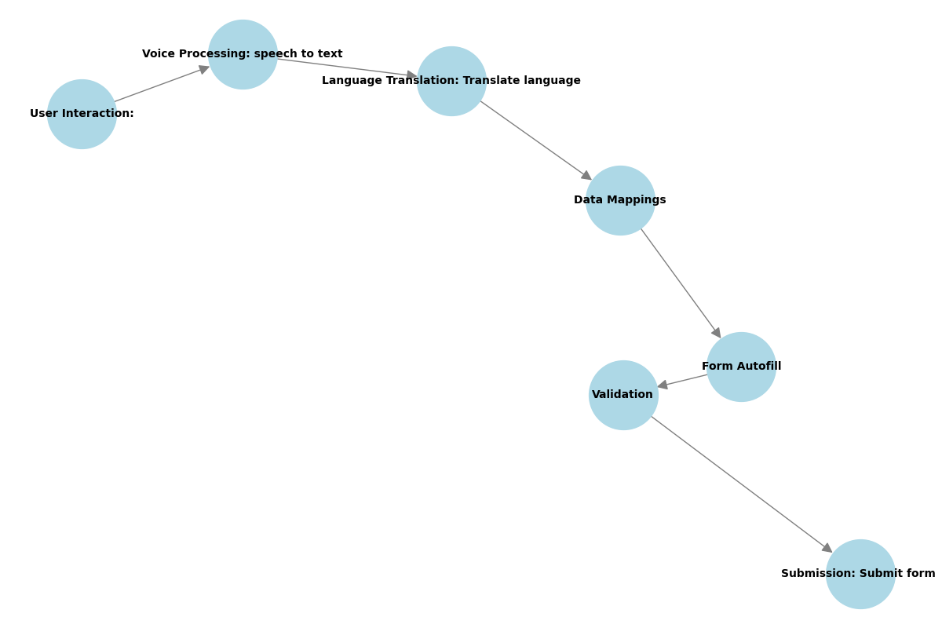
Flowchart of the Project

ROADMAP for Beyond QWERTY: Form Filling's Vernacular Voyage with Voice Versatility!
Phase 1: Project Setup and Data Collection
- Define Goals and Scope:
  - Clearly state the purpose: form-filling automation using voice input.
  - Identify tasks like multilingual transcription, translation, and form population.
- Setup Environment:
  - Install essential Python libraries in Google Collab
Phase 2: Speech-to-Text and Data Processing
- Integrate Azure Speech-to-Text API:
  - Convert voice inputs to text
- Text Preprocessing:
- Clean and structure the recognized text (e.g., tokenize and remove noise).
- Use NLP libraries like spaCy or NLTK.
Phase 3: Language Translation
Use Azure Translator or OpenAI Models:
  - Translate text into the required languages.
Phase 4: Automating Form Filling
Field Mapping:
- Design a mapping logic to match user input to form fields.
- Example: Map "My name is John Doe" → Name Field.
Phase 5: Testing and Validation
- Develop Test Cases:
  - Example: Input "I live in Kathmandu, Nepal" → Populate City and Country fields.
Phase 6: Deployment and Integration
- Build a Streamlit Interface:
  - Create a simple web app for user interaction

